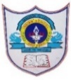 | INDIAN SCHOOL AL WADI AL KABIR  Social Movements (GRADE XII)  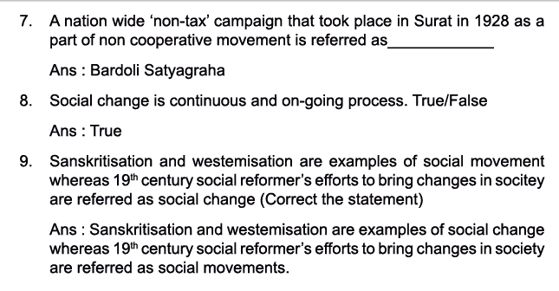  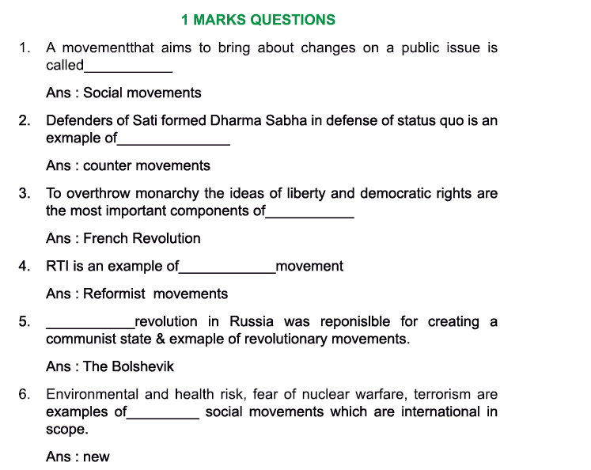  Question Bank
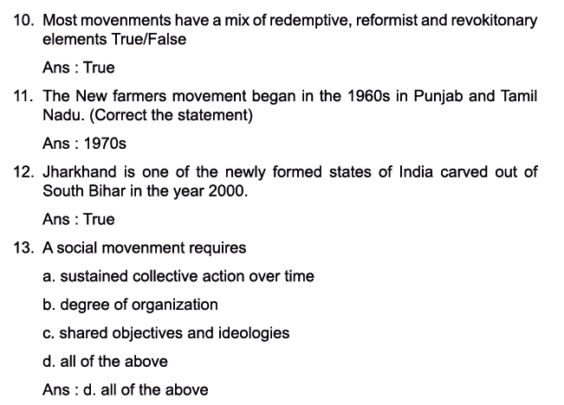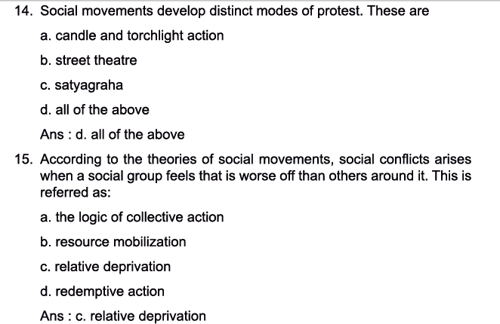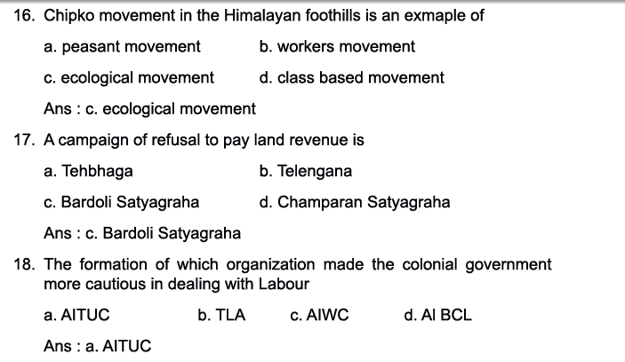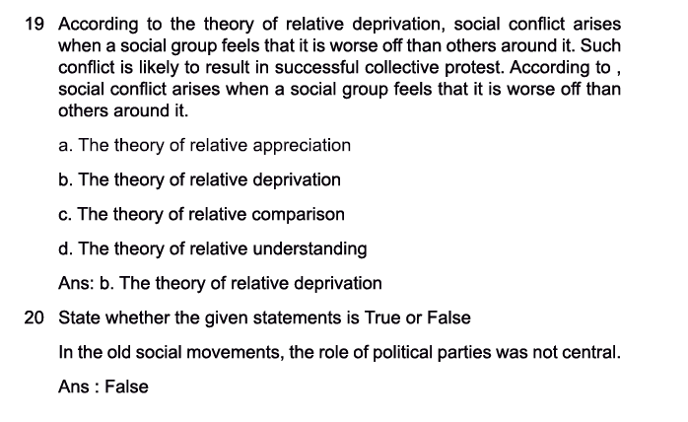
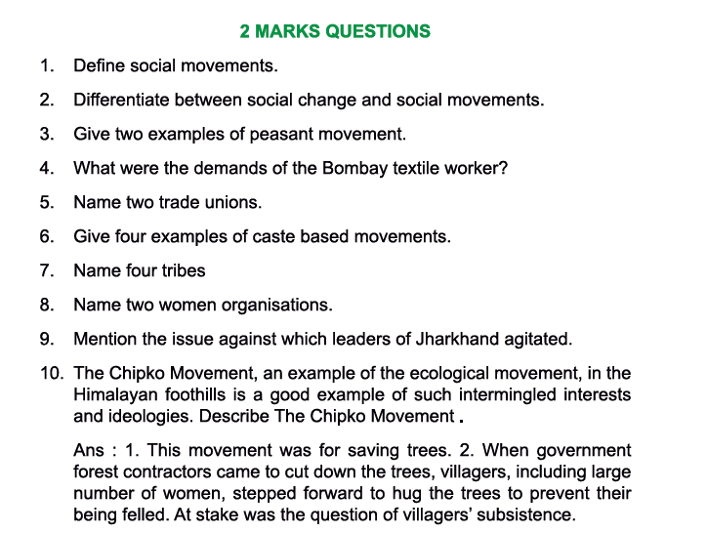
2-mark Questions
- Define Social Movements. Ans: A social movement essentially involves sustained collective mobilization through either informal or formal organization and is generally oriented towards bringing about change in the existing system of relationships. Ideology is an important component of a social movement.
- Differentiate between social change and social movements. Ans: Social change is continuous and ongoing and is a sum total of countless individual and collective actions gathered across time and space.
Social movements are directed towards some specific goals. It involves long and continuous social effort and action by people. e.g. Sanskritization and westernization are examples of social change and the 19th century social reformers efforts to change society are examples of social movements.

- Give two examples of peasant movements. Ans: At the time of Independence, we had the two most classical cases of peasant movements- namely the Tebhaga movement (1946-7) and the Telangana movement (1946-51). The first was a struggle of sharecroppers in Bengal & in North Bihar for two thirds share of their produce instead of the customary half. It had the support of the Kisan Sabha and the Communist Party of India (CPI). The second, directed against the feudal conditions in the princely state of Hyderabad and was led by the CPI.
- What were the demands of the Bombay Textile Workers? Ans: The Bombay Textile Strike of 1982 which was led by trade union leader Dr. Datta Samant and nearly affected a quarter of million workers fought for better wages and they also wanted the right to form their own union.
- Name two trade unions. Ans: In 1920 the All India Trade Union Congress (AITUC) was formed in Bombay. The AITUC was a broad-based organization involving diverse ideologies. The main ideological groups were the communists led by S.A. Dange and M.N. Roy, the moderates led by M. Joshi and V.V. Giri and the nationalists which involved people like Lala Lajpat Rai and Jawaharlal Nehru.
During the last few years of British rule, the communists gained considerable control over the AITUC. The Indian National Congress chose to form another union called the Indian National Trade Union Congress (INTUC) in May 1947.

- Give four examples of caste-based movements. Ans: The Satnami Movement of the Chamars in the Chattisgarh plains in eastern MP, Adi Dharma Movement in Punjab, the Mahar Movement in Maharashtra, the socio-political mobilization among the Jatavas of Agra and the Anti- Brahman Movement in South India are all examples of caste-based movements.
- Name four tribes. Ans: The tribes of India are largely located in the so called ‘tribal belt; in middle India are : Santhals, Hos, Oraons, Mundas in Chota Nagpur and the Santhal Parganas.
- Name two women’s organizations. Ans: The early 20th century saw the growth of women’s organizations at the national and local level. Some of these organizations were- The Women’s India Association (WIA- 1917), All India Women’s conference (AIWC- 1926) and the National Council for Women in India (NCWI- 1925)
- Mention the issues against which the leaders of Jharkhand agitated. Ans: The issues against which the leaders of the movement in Jharkhand agitated were as follows:
- acquisition of land for large irrigation projects and firing ranges
- Survey and settle operations, which were held up, camps closed down, etc.
- Collection of loans, rent and cooperative dues, which we resisted
- Nationalization of forest produce which they boycotted

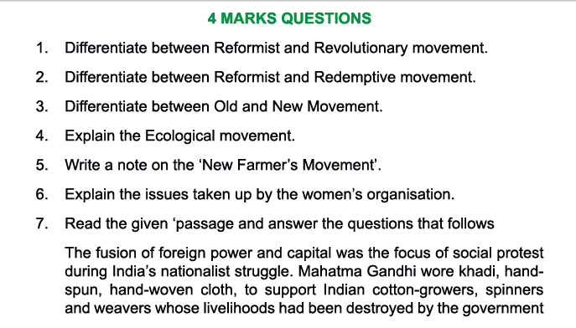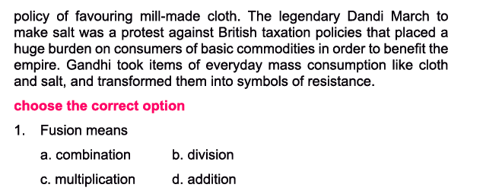
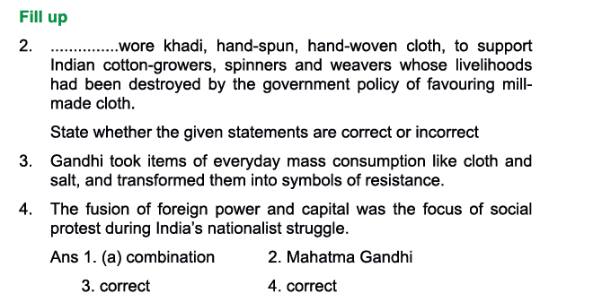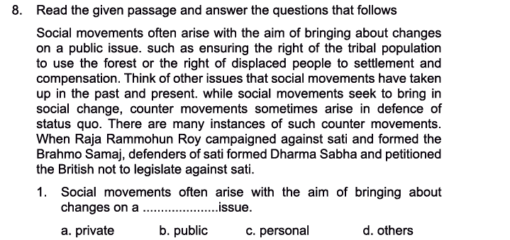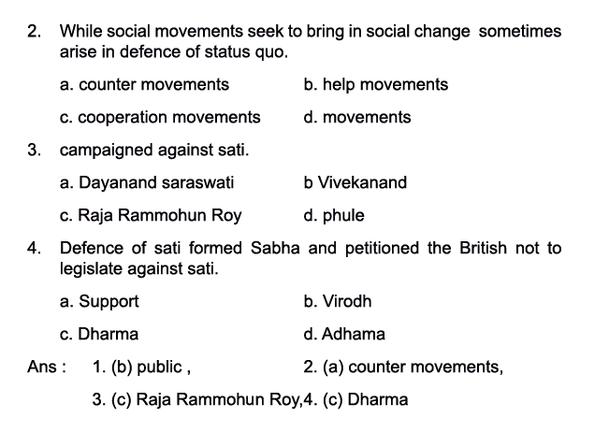
4 mark Questions
1. Differentiate between Redemptive, reformist, and revolutionary movement. Ans: There are different kinds of social movements. They can be classified as:
- redemptive or transformatory; (ii) reformist; and (iii) revolutionary.
A redemptive social movement aims to bring about a change in the personal consciousness and actions of its individual members. For instance, people in the Ezhava community in Kerala were led by Narayana Guru to change their social practices.
Reformist social movements strive to change the existing social and political arrangements through gradual, incremental steps. The 1960s movement for the reorganization of Indian states on the basis of language and the recent Right to Information campaign are examples of reformist movements.
Revolutionary social movements attempt to radically transform social relations, often by capturing state power. The Bolshevik revolution in Russia that deposed the Tsar to create a communist state and the Naxalite movement in India that seeks to remove oppressive
landlords and state officials can be described as revolutionary movements.

- Differentiate between old and new social movements. OR In India, it is difficult to make a clear distinction between the old and new social movements. Discuss.
Ans. Old Social Movements
•Class based – united to fight for rights.
•Anti-colonial movements.
• Nationalist movement united people into a nation e.g, liberation struggle.
•Movement against colonialism.
•Nationalist movement mobilized against rule of foreign power and dominance of foreign capital.
•Mainly concerned with struggles between haves and have-nots. Key issue is reorganization of power relations, i.e. capturing power & transferring it from powerful to powerless, e.g. Workers were mobilized towards capitalists; Women’s struggle against male domination.
•Worked under guidance & organizational framework of political parties, e.g. Indian National Congress led the Indian National movement; Communist Party of China led the Chinese Revolution.
•Role of political parties was central and poor people had no other effective means to get their voices heard.
•Concerned about social inequality and unequal distribution of resources -important elements.
New Social Movements
•Decades after Second World War- 1960s and early 1970s
•Took up not just narrow class issues but broad, universal themes, which involved a broad social group irrespective of their class.
•Vietnam where forces led by US were involved in a bloody conflict.
•Paris – Vibrant student’s movement joined worker’s parties in a series of strikes
protesting against the war.
•USA was experiencing a surge of social protests. Civil rights movement was led by Martin Luther King.
•Black powers movement led by Malcolm X.
•Women’s movement, environmental movement.
•No longer focus on redistribution of power rather are more concerned with improving the quality of life e.g. Right to education, clean environment.
•No longer confine themselves within political parties. Instead started joining civil society movements and forming NGOs because they are supposed to be more efficient, less corrupt and less autocratic
•Globalization – reshaping people’s lives, culture, media Films – transnational. Legal arrangements – international.
Therefore, many new social movements are international in scope.
•Essential elements – Identity politics, cultural anxieties and aspirations.

- Explain the ecological movement. OR Environmental movements often also contain economic and identity issues. Discuss.
Ans. The Chipko movement is a suitable example of an ecological or environmental movements. It is an appropriate example of intermingled interests and ideologies. Ramchandra Guha says in his book ‘Unquiet Woods’ that villagers came together to save the oak and rhododendron forests near their villages. The government forest contractors came to fell the trees but the villagers, including large number of women, came forward to hug the trees to check their being felled. The villagers relied on the forest to get firewood, fodder and other daily requirements. It was a conflict between livelihood needs of poor villagers and government’s desire to make revenue from selling timber.
Chipko movement raised the issue of ecological sustainability. Felling down natural forests was a form of environmental destruction which resulted in demonstrating floods and landslides in the area. Therefore, concerns about economy, ecology and political representation underlay the Chipko movement.

- Write a note on the ‘New farmer’s movement’. Ans: (repeated as part of 6mark question)

- Explain the issues taken up by the women’s organizations.
Ans. (i) Women’s Movement: The early 20th Century saw the growth of women’s organizations such as ‘Women’s India Association (WLA) (1917)’ All India Women’s Conference (AIWC) (1926), ‘National Council for Women in India (NCWI) (1925)’. While many of them began with a limited focus, their scope extended overtime.
It is often assumed that only middle class educated women were involved in social movements.
But part of the struggle is to remember the forgotten history of women’s participation. Women participated along with men in struggles and the revolt originated in tribal and rural areas in the colonial period. Thus, not only urban women but also rural and tribal women participated in political agitations struggles, gradually empowering themselves.
The mid-1970s saw the second phase of Indian women’s movement. There was growth of autonomous women’s movement, i.e., they were independent from political parties as well as women’s organizations that had links with political parties.
Educated women took active part in radical politics. This simultaneously promoted an analysis of women’s movement. New issues were now being focused upon such as violence against women, application for schools’ forms had both father’s and mother’s name: legal changes such as land rights, employment, rights against sexual harassment and dowry. The Mathura rape case (1978), Maya Tyagi rape case (1980) which were both cases of custodial rape led to major nationwide protests.
In conclusion, it is important to recognize that in women’s movements, there is bound to be disparity because women belong to different classes and thus their needs and concerns are bound to be different.

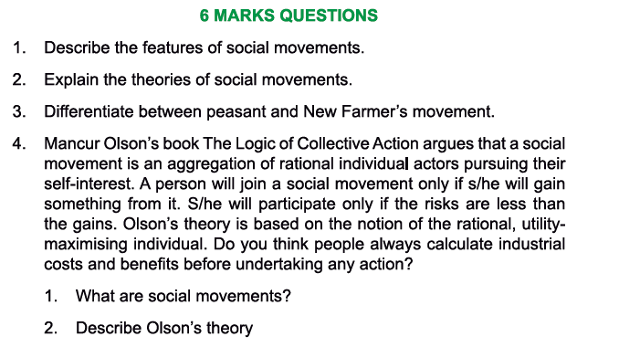
6mark questions:
- Describe the features of social movements. Ans: Social movements have shaped the world we live in and continue to do so. Some of its main features are as follows:
- Sustained collective mobilization: A social movement requires sustained collective action over time. Such action is often directed against the state and takes the form of demanding changes in state policy or practice. Spontaneous, disorganized protest cannot be called a social movement.
- Organizational structure and leadership: Collective action must be marked by some degree of organization. This organization may include leadership and a structure that defines how members relate to each other, make decisions and carry them out.
- Shared objective and ideologies: Those participating in a social movement also have shared objectives and ideologies. A social movement has a general orientation or way of approaching to bring about (or to prevent) change. These defining features are not constant, they may change over the course of a social movement’s life.
- Aim of bring about change on a public issue: Social movements often arise with the aim of bringing about changes on a public issue, such as ensuring the right of the tribal population to use the forests or the right of displaced people to settlement and compensation

- Explain the theories of social movements. Ans: There are 3 main theories of social movement. The first one is called the ‘Theory of Relative deprivation’ which states that social conflict arises when a social group feels that it is worse off than another around it. Role of psychological factors such as resentment and rage have a role to play. The limitations of this theory are that while perceptions of deprivation may be a necessary condition for collective action, but it isn’t a sufficient reason in and of itself.
The second theory is explained in a book the ‘The logic of collective action’ written by Mancur Olson. This theory argues that a social movement is an aggregation of rational individual actors pursuing their self- interest. A person will join a social movement only of she/he will gain something from it. Mccarthy and Zald rejected Olson’s assymtption that social movements are made up of individuals pursuing their self- interest.
The third theory called the ‘Resource Mobilization theory’ depends on the ability to mobilize resources or means of different sorts. Critics argue that a social movement is not limited by existing resources. It can create resources such as new symbols and identities. Scarcity of resources need not be a constraint.

- Differentiate between peasant and the ‘new farmer’s movement’.
Ans. (i) Peasant movements have taken place from pre-colonial days. The movement took place between 1858 and 1914 remained localized, disjointed and confined to particular grievances. The well-known movement are:
•Bengal Revolt of 1859 – 62 against the indigo plantation system.
•Deccan Riots of 1857 against money lenders.
•The Bardoli Satyagraha – 1928 was a non-tax campaign started by Gandhi.
•Champaran Satyagraha 1917-18. It was directed against indigo plantations.
•Tebhaga movement (1946-47): write a sentence on this
•Telangana movement (1946-51): write a sentence on this
(ii) New farmer’s movement started in 1970s in Punjab and Tamil Nadu. Main Characteristics:
•Movements were regionally organized.
•Movements were non-party.
•Movements involved farmers rather than peasants.
•Main ideology- Strongly anti-state and anti-urban
•Focus of demand – Price related issues.

Textbook Questions:
Write a note on the Tribal Movement
(i) Tribal Movements: Most of the tribal movements have been largely located in the so called “tribal belt” in middle India, such as the Santhals, Hos, Oraons, Mundas in Chota Nagpur and the Santhal Parganas.
The social movement of Jharkhand had a charismatic leader in Birsa Munda, an Adivasi who led a major uprising against the British.
His memory has still been kept alive and has continued to be a source of inspiration for generation. An educated middle class among the tribals was created by the Western education given by Christian missionaries. This educated class developed an ethnic consciousness – awareness of their identity, culture and customs. A sense of marginalization brought together the tribal population of South Bihar. They identified their common enemies – dikus—migrant traders, money lenders. The Adivasis in senior government jobs provided organizational intellectual leadership to the movement and negotiated and lobbied for the creation of their own state on the following issues—acquisition of land for large irrigation projects; survey and settlement operations, which were held up, camps closed, etc.; collection of loans, rent and cooperative dues; nationalization of forest produce.
As far as the North Eastern tribes were concerned, main issues taken up were – ascertain distinct tribal identity of the region; demanding of the traditional autonomy of tribes; misunderstanding & lack of communication in Indian mainstream society which needs to be bridged;
•Rights of the tribes to maintain their own social cultural institutions along with a connection with the rest of India;
•Anger of tribes because of the loss of their forest lands.
Thus, tribal movements are good examples of social movements, which incorporates many issues – economic, cultural, ecological.
Earlier many tribal regions of North East, showed tendencies of separating from India but today they have adopted a balanced approach of asking for autonomy with the framework of Indian institution.

